STUDENT NOTES EXCHANGE PORTAL

Submitted as Part of the Course
SEC 174 – FULL STACK DEVELOPMENT -2



Group Details
Sl. No | Reg. No. | Name
1 | AP23110011052 | Ch. Jaswanth
2 | AP23110011047 | P. Vishwanadh
3 | AP23110011049 | G. Vishnu Keshav
4 | AP23110011041 | M. Yoshi Anurag
5 | AP22110011624 | K. Bhavith Kalyan

SRM University-AP
MAY-2026

Student Notes Exchange Portal
INTRODUCTION:
NoteVault is a versatile, modern, and user-friendly web application designed to streamline the sharing, discovery, and management of academic resources. Suitable for university students, educators, and academic institutions, it offers a centralized platform where users can upload and download study materials, including lecture notes, full textbooks, and branch-specific guides.
The platform offers a wide range of features—including secure user authentication, intelligent filtering by branch and semester, rich metadata tagging, and direct PDF file downloads—arranged within a sleek, highly responsive user interface built on Tailwind CSS. Users can interact with the community by rating notes, bookmarking essential materials for exam preparation, and reporting low-quality content.
Robust security features like JSON Web Token (JWT) encryption, bcrypt password hashing, and role-based access control help protect data integrity. NoteVault integrates seamlessly with MongoDB for fast data retrieval and offers scalable file storage options (local or Cloudinary). With built-in administrative tools, moderators can view platform analytics, manage user accounts, and resolve reported content. Its flexibility, ease of use, and powerful MERN-stack architecture make it an ideal choice for fostering a collaborative academic environment.

SCENARIO Based Case Study:
Meet Rahul, a second-year Computer Science Engineering (CSE) student with a demanding academic schedule who values efficiency in his exam preparation. Rahul frequently struggles to find reliable, high-quality lecture notes and textbooks right before his exams. Relying on fragmented WhatsApp groups and messy Google Drive folders requires him to waste hours searching for specific subjects like "Data Structures" or "Operating Systems."
Rahul discovers NoteVault, a comprehensive web application designed to streamline the exchange of student notes. Intrigued by its organized structure, Rahul decides to explore how NoteVault can help him enhance his academic productivity.
- User Registration and Authentication: Rahul registers an account on NoteVault, providing his academic details (Branch: CSE, Semester: 3). He logs in securely using his credentials, ensuring that his bookmarks and profile data remain private.
- Resource Discovery & Search: Rahul explores NoteVault's extensive note catalog. He uses the smart search bar and filters specifically for "CSE" and "Semester 3". The system instantly provides him with top-rated PDFs on his required subjects.
- Downloading & Rating: Rahul easily downloads a textbook on Eloquent JavaScript. Finding it incredibly helpful, he leaves a 5-star rating, which boosts the note's visibility for other students.
- Bookmarking: To prepare for finals, Rahul bookmarks several crucial files. He can now access all of them instantly from his personalized Dashboard without having to search for them again.
- Contributing (Upload Management): After acing his exams, Rahul decides to give back. He uses the Upload feature to share his own handwritten notes on "Database Management Systems," adding appropriate tags. He tracks his contribution through the "Total Downloads" metric on his profile, building his academic reputation.
Rahul's Experience: Thanks to NoteVault, Rahul can now manage his study materials efficiently. He focuses on learning rather than searching for resources. NoteVault has become an indispensable tool in his academic journey, helping him achieve his goals with ease.

SYSTEM REQUIREMENTS:
1. Software Requirements
These are the essential tools and platforms required to develop, test, and run the application efficiently.
- Operating System: Windows 10/11, macOS, or Linux — Supports cross-platform development and deployment.
- Node.js (v18 or above): Provides the runtime environment for executing server-side logic and managing the Express.js API routing.
- npm / Vite: Package manager required to install dependencies and Vite as the ultra-fast build tool for the React frontend.
- React.js: A JavaScript library used for building dynamic, single-page user interfaces.
- Browser: Google Chrome / Firefox / Safari (latest version) — For rendering the application.
- Express.js: A lightweight web framework used to build the RESTful backend API.
- MongoDB: A NoSQL database used to securely store structured data related to users, notes, bookmarks, and moderation reports.
2. Hardware Requirements
Describes the minimum specifications needed to support development and server hosting.
- Processor: Intel Core i5 (8th Gen or above) / AMD Ryzen 5 or better.
- RAM: Minimum 8 GB (16 GB recommended) for running the local frontend/backend servers concurrently.
- Storage: At least 1 GB free space for project files and local MongoDB storage.
- Display: 1366x768 or higher recommended for optimal UI layout visualization.

PROJECT ARCHITECTURE:
TECHNICAL ARCHITECTURE:

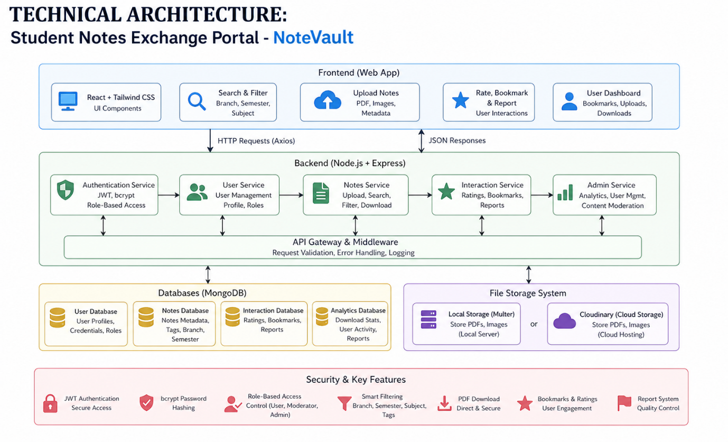

In this architecture, the flow begins with a user interacting with the NoteVault Frontend (built with React and Tailwind CSS). The user triggers an action, such as uploading a note or searching for a subject.
The frontend sends an asynchronous HTTP request (via Axios) to the NoteVault Backend (built with Node.js and Express). The backend intercepts this request, validates the JWT authorization token, and processes the business logic.
The backend communicates with the MongoDB Database to store or retrieve data (e.g., fetching a list of notes matching a search query, or inserting a new user record). For file uploads, the backend utilizes a File Storage System (Multer for local storage, or Cloudinary for cloud hosting) to save the physical PDF or image file and returns the secure URL.
Once the backend has processed the request and updated the database, it sends a JSON response back to the frontend. The React frontend then updates its state and dynamically displays the results (e.g., showing the newly uploaded note) to the user without reloading the page.

ER DIAGRAM (Entity Relationship Description):

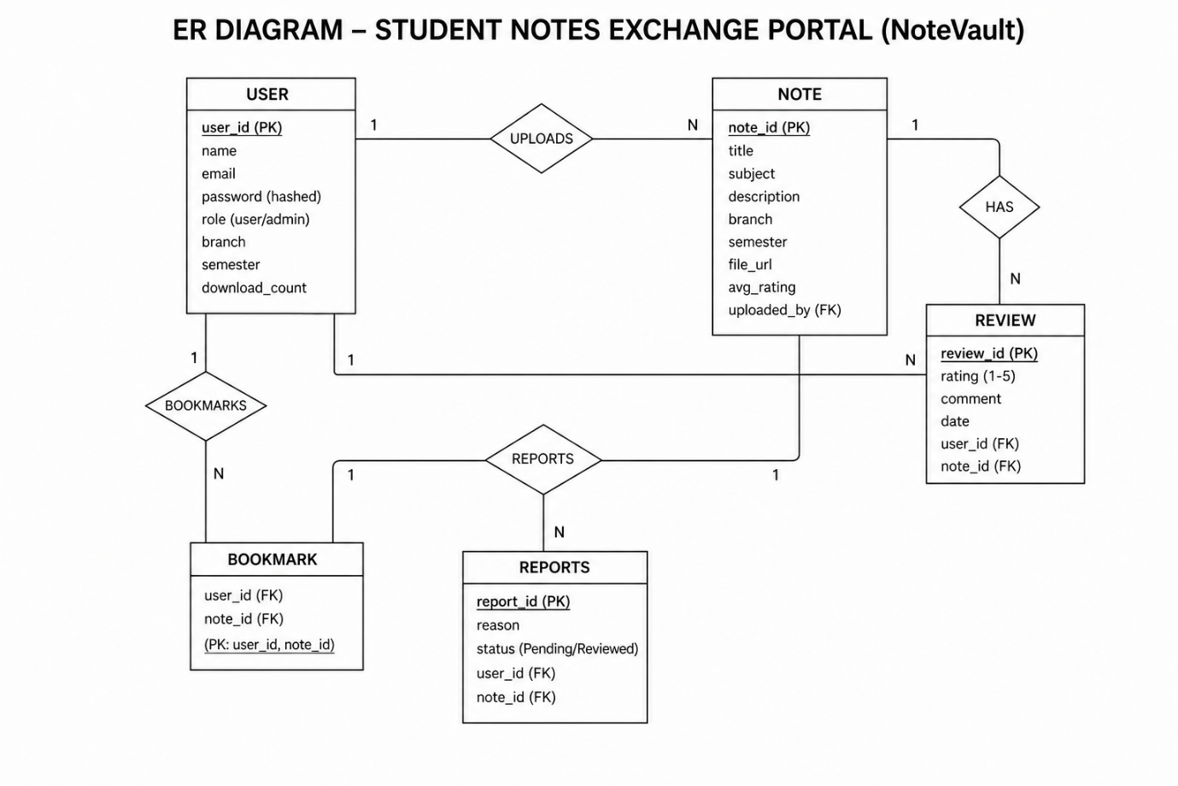

The Entity-Relationship architecture for NoteVault represents the various entities and their relationships within the platform.
1. Entities:
- User: Represents students and admins registered on the platform.
  - Attributes: User ID, Name, Email, Password (hashed), Role (user/admin), Branch, Semester, Download Count.
- Note: Represents the academic materials shared on the platform.
  - Attributes: Note ID, Title, Subject, Description, Branch, Semester, File URL, Average Rating.
- Review: Represents user feedback on a specific note.
  - Attributes: Review ID, Rating (1-5), Comment, Date.
- Report: Represents a moderation flag raised against inappropriate content.
  - Attributes: Report ID, Reason, Status (Pending/Reviewed).

2. Relationships:
- User ↔ Note (One-to-Many): A User (uploader) can upload multiple Notes. Each Note is tied to exactly one Uploader.
- User ↔ Note (Many-to-Many / Bookmarks): A User can bookmark multiple Notes, and a Note can be bookmarked by multiple Users.
- User ↔ Review (One-to-Many): A User can write multiple Reviews, but only one per specific Note.
- Note ↔ Review (One-to-Many): A single Note can have multiple Reviews from different users.
- User ↔ Report (One-to-Many): A User can flag multiple Reports against various notes.

KEY FEATURES:
- User Registration and Profiles: Secure account creation using JWT authentication. Users can define their engineering branch and current semester for a personalized experience.
- Resource Management (Upload/Download): Students can seamlessly upload PDF files or image-based notes. The system tracks the number of times a user's uploaded materials have been downloaded.
- Smart Filtering & Search: A powerful query engine allowing users to instantly filter hundreds of notes by Subject, specific Branch, Semester, or sort them by highest rating.
- Reviews and Ratings: A 5-star rating system enabling users to evaluate the quality of study materials, pushing the best content to the top of the search results.
- Personal Dashboard & Bookmarks: A private space where users can save essential notes for later, track their total uploads, and manage their profile details.
- Admin Moderation Panel: A dedicated portal for Administrators to monitor platform health (total users, total notes), review flagged/reported content, and delete inappropriate materials to maintain academic integrity.

ROLES AND RESPONSIBILITIES:
1. User (Student)
- Registration: Creating an account and managing personal profile details (branch, semester).
- Content Contribution: Uploading accurate, high-quality, and relevant academic notes in PDF/Image formats.
- Content Evaluation: Leaving honest ratings and reviews on downloaded materials to help peers.
- Community Safety: Reporting any spam, copyrighted, or irrelevant materials to the administration.

2. Administrator
- Platform Monitoring: Overseeing the overall flow of notes and user registrations.
- Content Moderation: Reviewing user-submitted reports and taking necessary actions (dismissing false reports or deleting violating notes).
- System Maintenance: Ensuring that the database schemas remain uncorrupted and that the platform maintains high educational standards.

USER FLOW:
Student Flow
- Registration & Account: Create and manage account details securely.
- Search & Discovery: Find notes by filtering through specific branches and semesters.
- Upload: Submit new study materials via the upload form.
- Download & Bookmark: Save specific notes for offline or quick access.
- Review & Feedback: Leave honest ratings and reviews on downloaded materials.
Admin Flow
- System Management: Oversee platform analytics and metrics.
- User Management: Manage user accounts if intervention is required.
- Content Moderation: Verify, approve, or delete reported notes to maintain content quality.

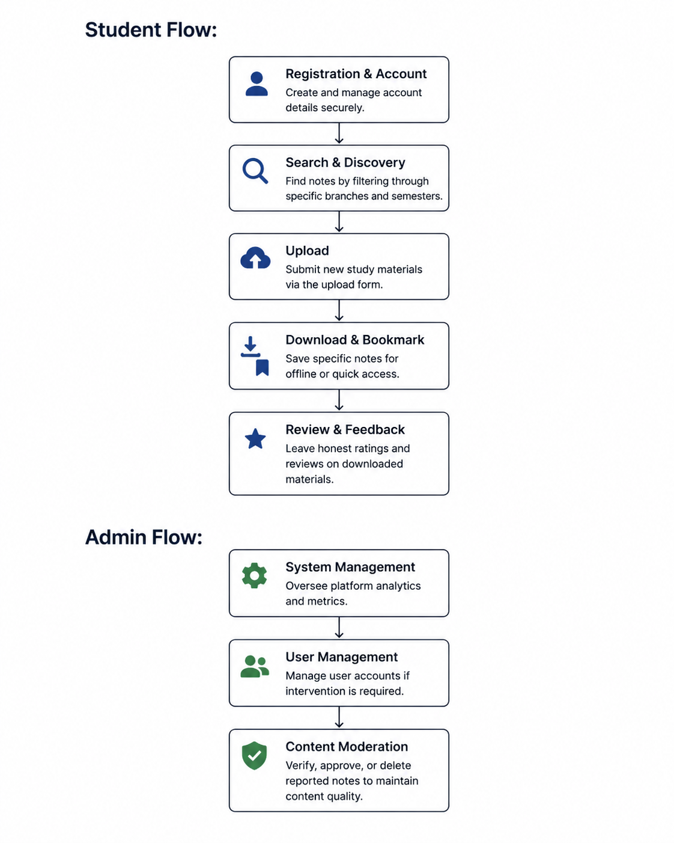

MVC PATTERN:

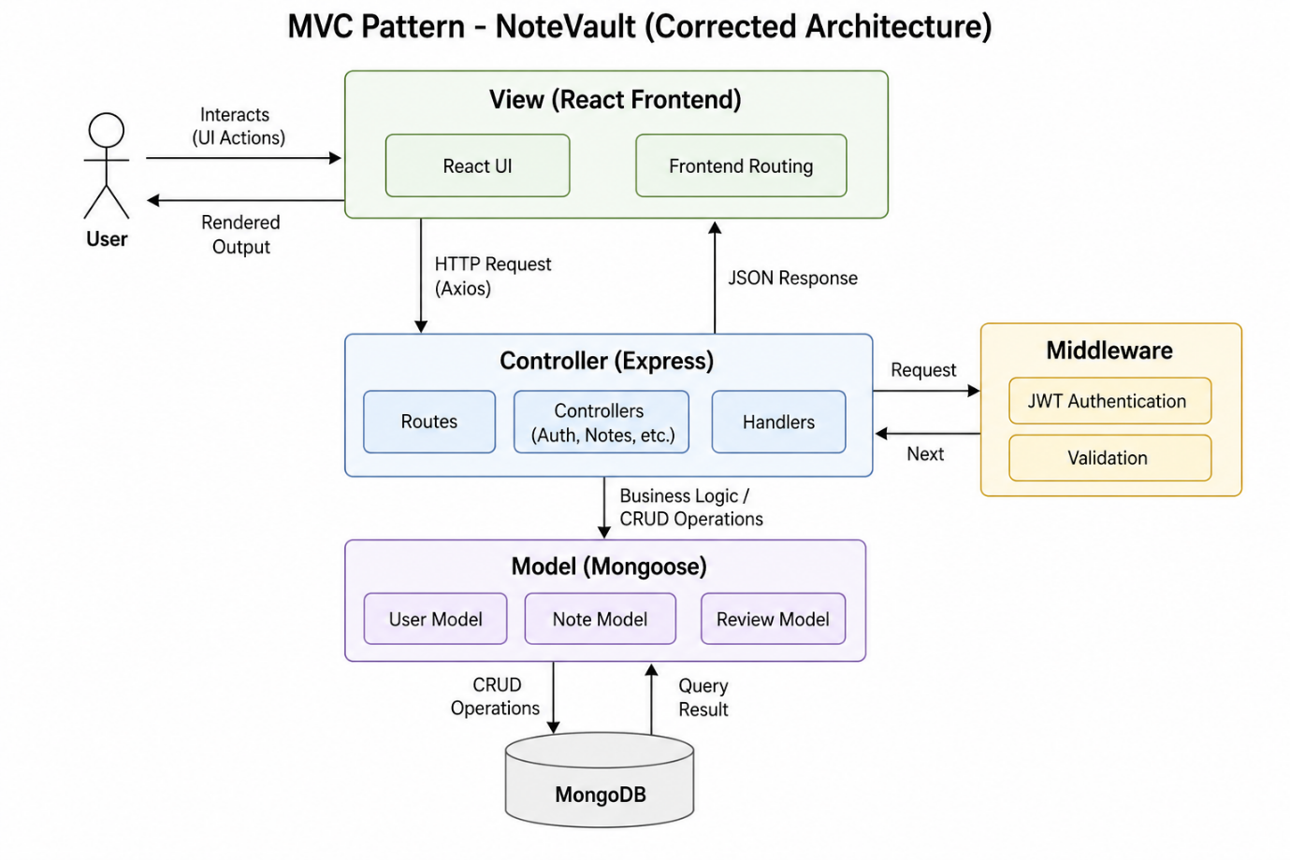

The NoteVault application follows the Model-View-Controller (MVC) architectural pattern, a software design approach that separates the application into three interconnected layers. This separation allows for modularity, easier maintenance, and scalability.
Model Layer (Data Layer)
The Model layer handles all data-related logic. This includes the definition of data schemas and the operations performed on the database. Models are implemented using Mongoose, which provides a schema-based solution to model application data for MongoDB (e.g., User.js, Note.js).
Controller Layer
The Controller layer acts as an intermediary between the routes and the models. It receives incoming HTTP requests, processes the input, validates credentials, calls appropriate Mongoose methods, and returns a JSON response to the client (e.g., authController.js, notesController.js).
View Layer (Routing Layer / Frontend UI)
For the backend API, the View is implemented as the routing layer, where various RESTful endpoints are defined to respond to GET, POST, PUT, and DELETE requests. The actual visual View layer is fully detached and handled independently by the React Frontend.
Advantages of Using MVC in This Project:
- Separation of Concerns: Each layer has a clearly defined responsibility, improving code readability.
- Scalability: New features can be added quickly without breaking existing logic.
- Reusability: Functions in controllers and models can be repurposed across different routes.

Project Setup And Configuration.
Creating project folder
1. Create a new folder with your <project name>.
2. Inside that folder create two new folders.
3. Name one as Frontend.
4. Name another one as Backend.
5. Now open that folder in VS Code.

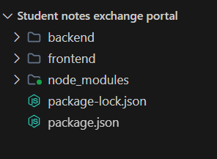

Client Setup (React App):
Navigate to the frontend directory.
Install dependencies using: npm install
Configure the .env file to point to the backend API (VITE_API_URL=http://localhost:5000).
Run the development server using: npm run dev

Server Setup (Node/Express API)
Navigate to the backend directory.
Initialize and install dependencies: npm install
Configure the .env file with PORT, MONGO_URI, and JWT_SECRET.
Run the development server using: npm run dev (starts nodemon). Note: We have also configured a root-level script to start both simultaneously using npm run dev:all.

Backend Structure:
- Controllers
  - authController.js → Handles user registration, login, and profile updates.
  - notesController.js → Handles CRUD operations for notes, file uploads, and search queries.
  - adminController.js → Handles admin dashboard analytics and resolving reports.
- Config
  - db.js → Contains MongoDB connection setup.
- Middleware
  - auth.js → Middleware for JWT token validation and role-based access control.
  - upload.js → Middleware utilizing Multer for handling multipart/form-data file uploads.
- Models (Mongoose Schemas)
  - User.js → Schema for User accounts.
  - Note.js → Schema for Uploaded Notes.
  - Report.js → Schema for Moderation Reports.
- Routes
  - auth.js, notes.js, admin.js → Defines API endpoints for their respective controllers.
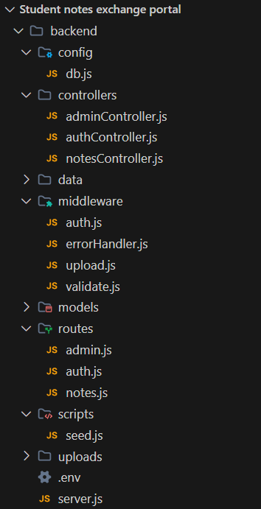

DATABASE DEVELOPMENT:
- Configure MongoDB: The project uses Mongoose as the ODM. npm install mongoose was run to manage connections.
- Create Database Connection: Inside config/db.js, an async function establishes a secure connection to the MONGO_URI.
- Create Schemas: ER diagrams were translated into robust Schemas with validation. For example, User.js contains a pre('save') hook to automatically encrypt passwords before they are inserted into the database.

User.js:

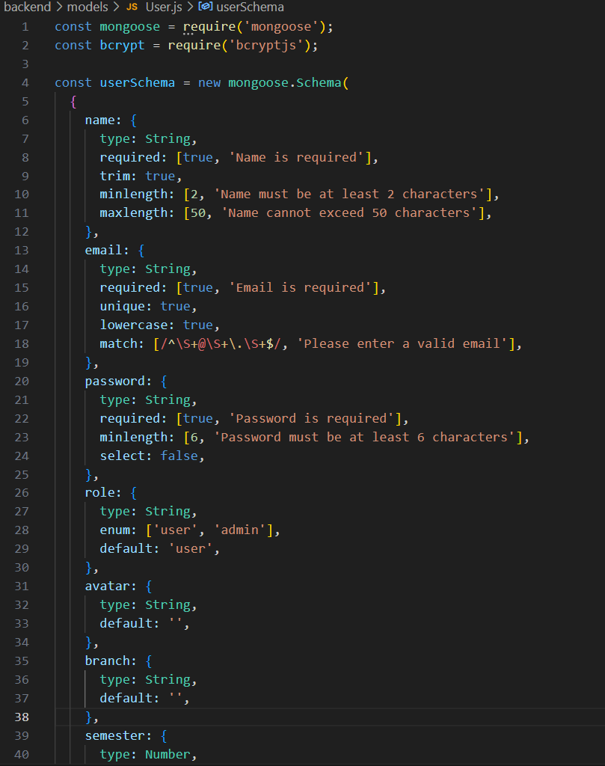

Note.js:
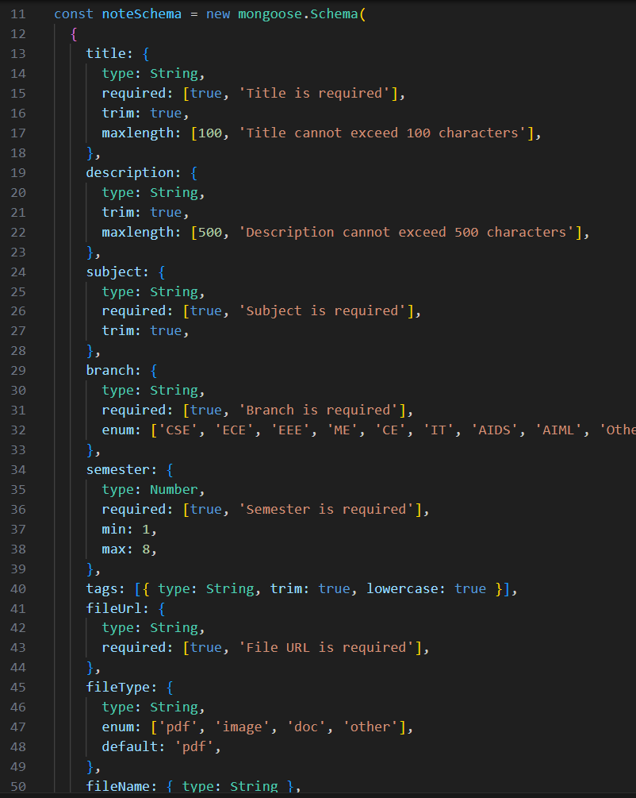

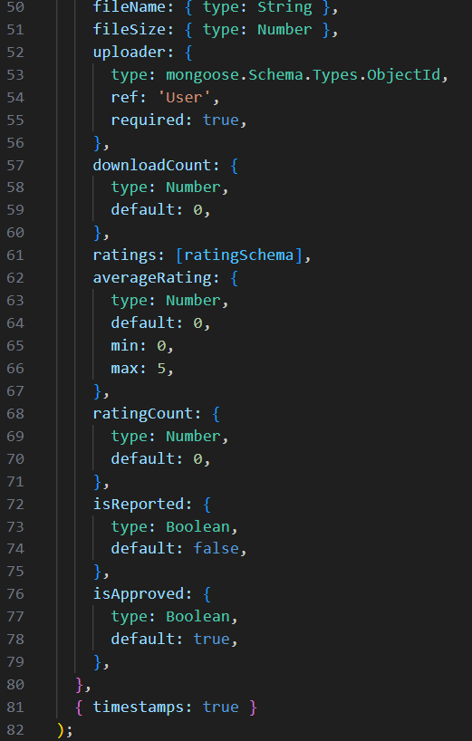

Report.js:
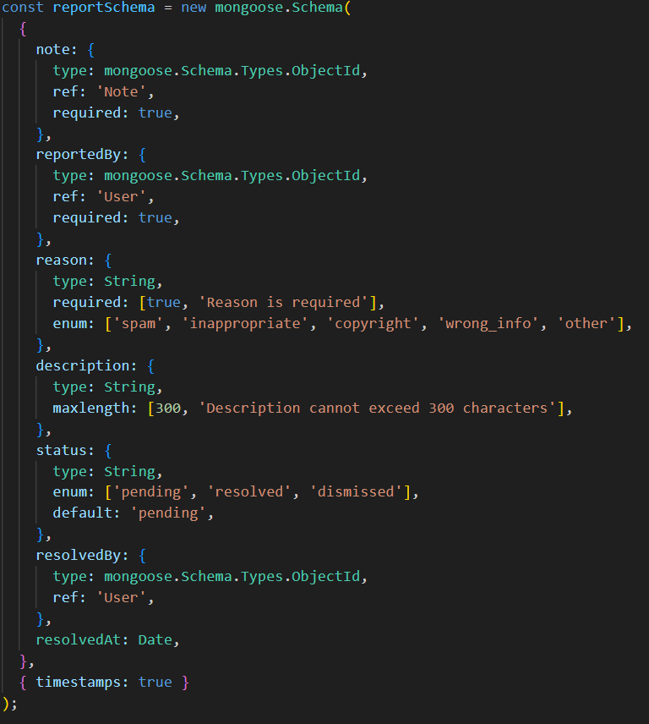

Frontend Structure:
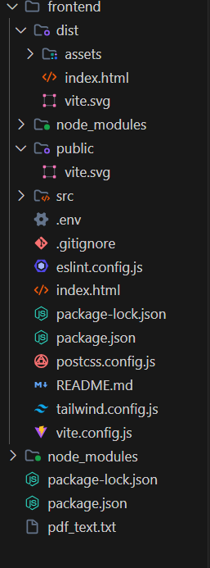

Frontend Structure (frontend/src/):
- Pages
  - HomePage.jsx → Main landing page with hero section and statistics.
  - LoginPage.jsx / RegisterPage.jsx → User authentication portals.
  - NotesListPage.jsx → The primary Explore page to search and filter notes.
  - NoteDetailPage.jsx → Detailed view of a single note including PDF viewing, reviews, and download buttons.
  - UploadPage.jsx → Form for users to contribute notes to the platform.
  - DashboardPage.jsx → Private user dashboard displaying bookmarks and upload statistics.
  - AdminPage.jsx → Private dashboard for administrators to manage reports and users.
  - AboutPage.jsx → Information regarding platform mission and values.

- Components
  - Navbar.jsx → Responsive navigation bar with integrated search.
  - NoteCard.jsx → Reusable UI card component for displaying note summaries.
  - FilterPanel.jsx → Sidebar component for handling branch/semester filters.
  - ProtectedRoute.jsx → Wrapper component to prevent unauthorized access to private routes.

Output ScreenShots:
Landing Page:
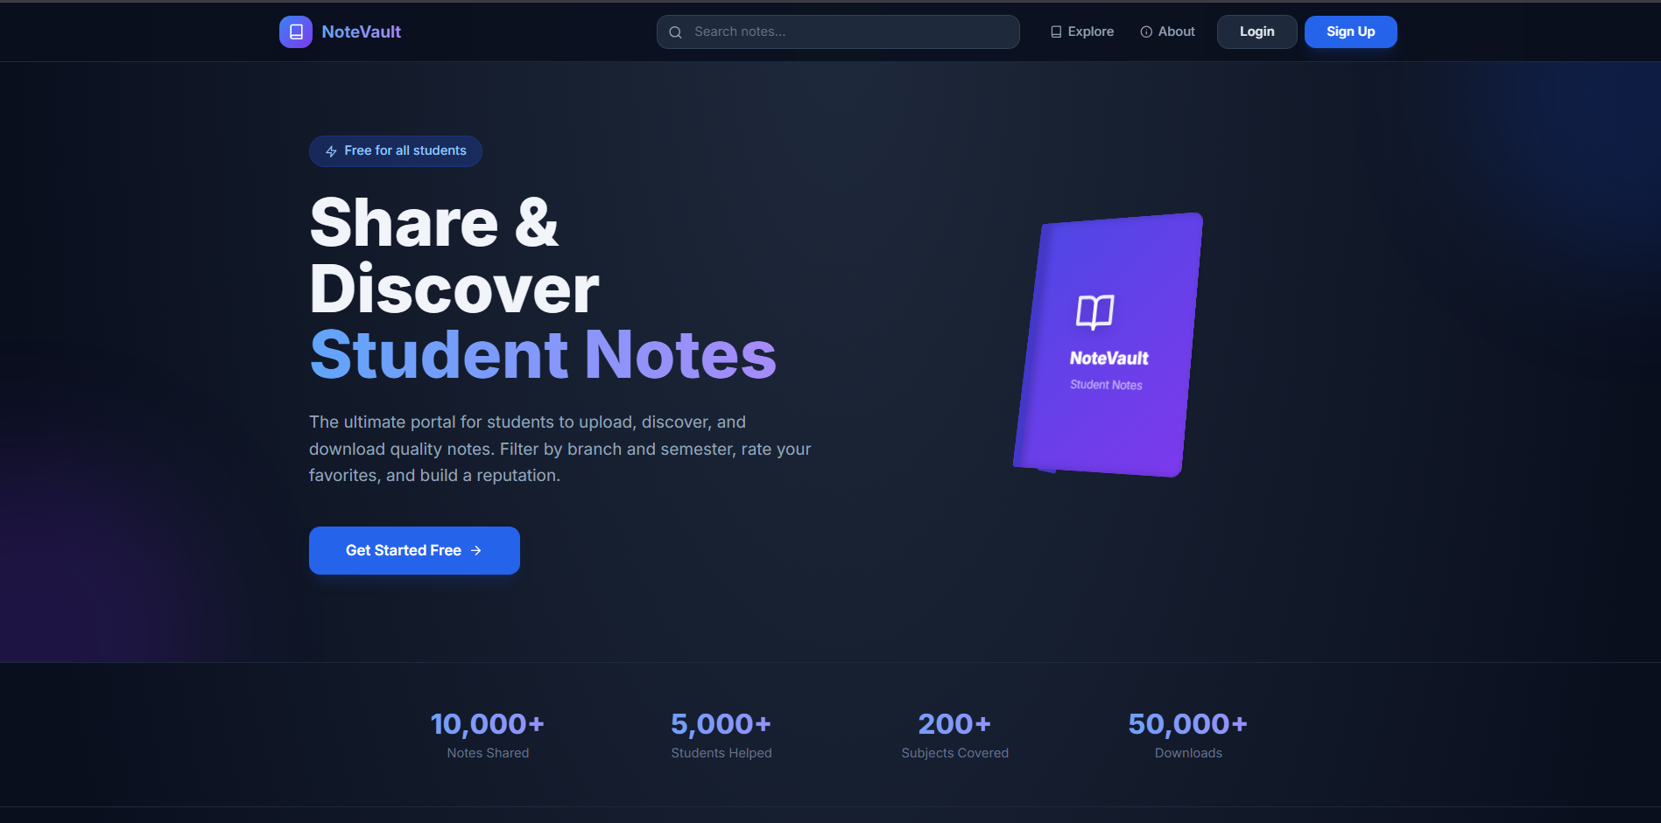
UserRegistrationPage:
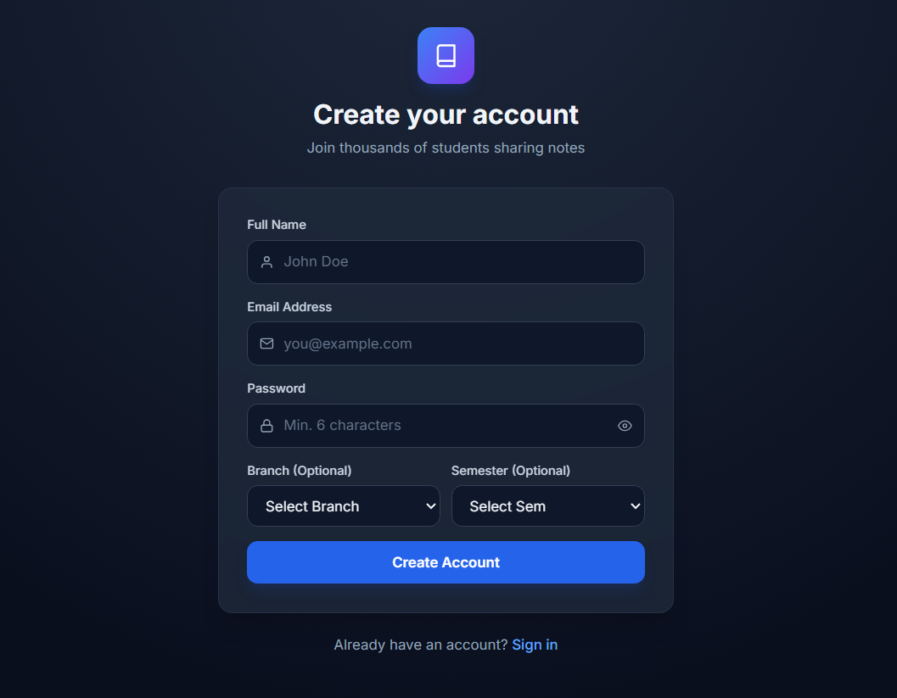

User Login Page:
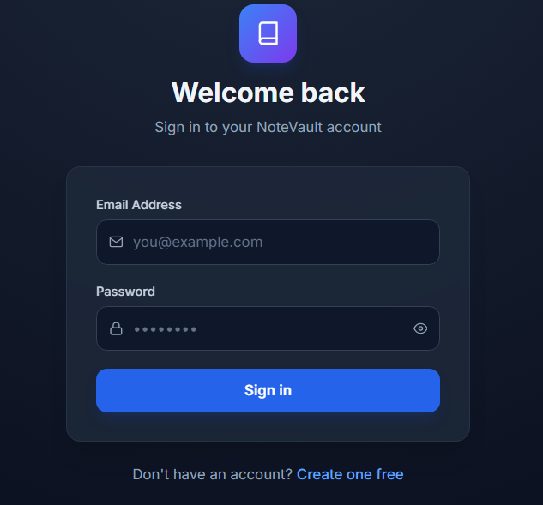

Explore Notes Page:
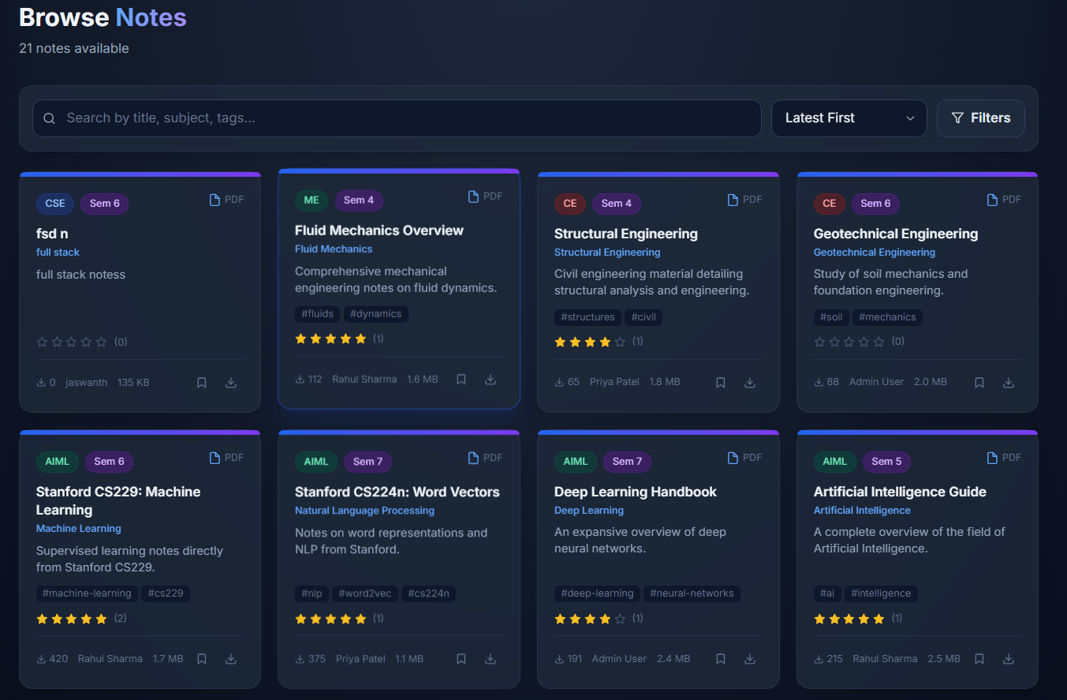

Note Detail & Download Page:
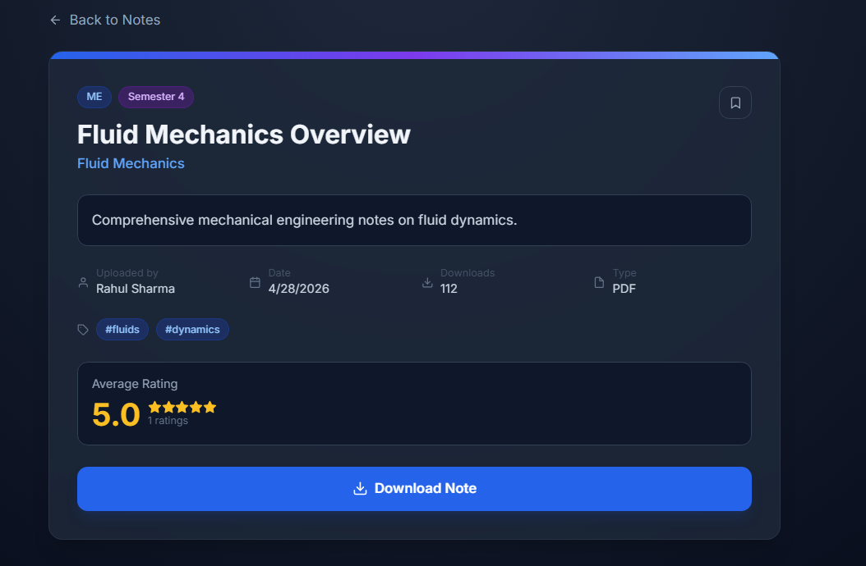

Upload Form Page:
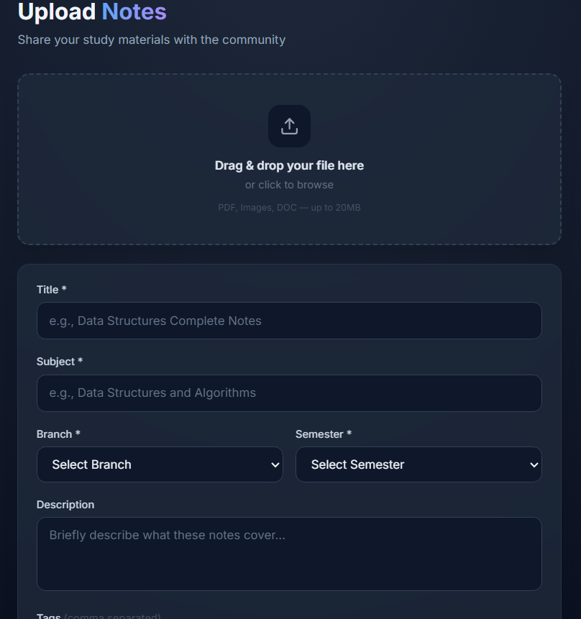
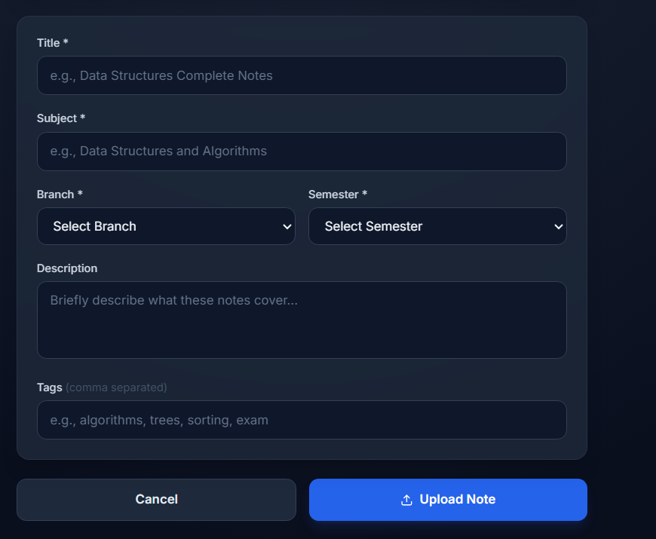

Personal Dashboard:
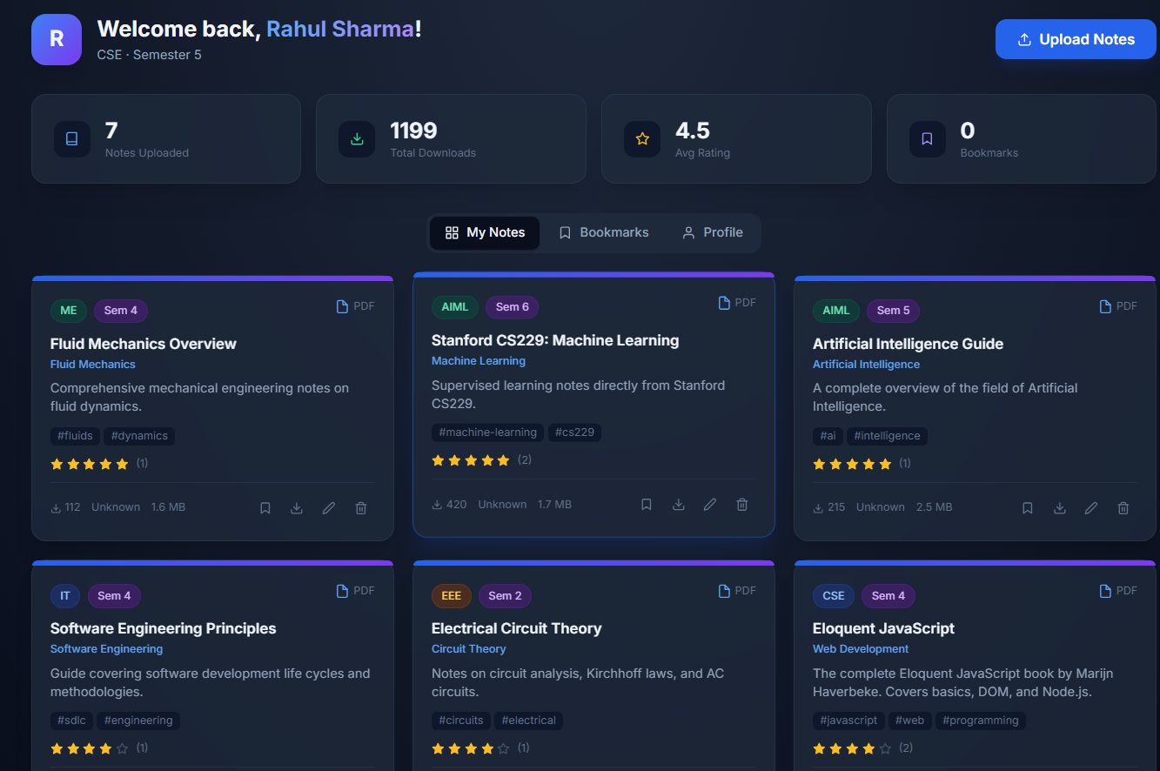

Admin Dashboard:
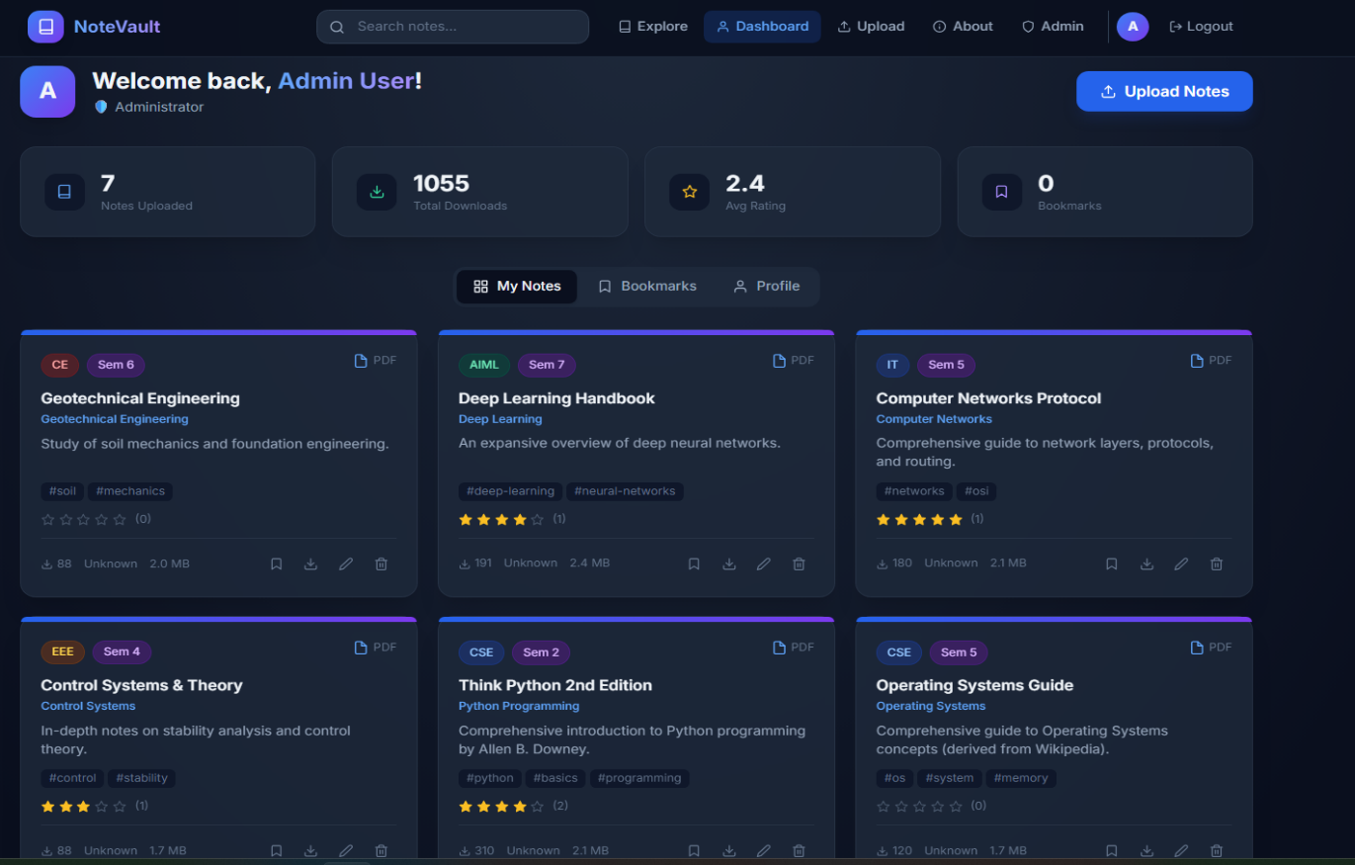

About Us Page:
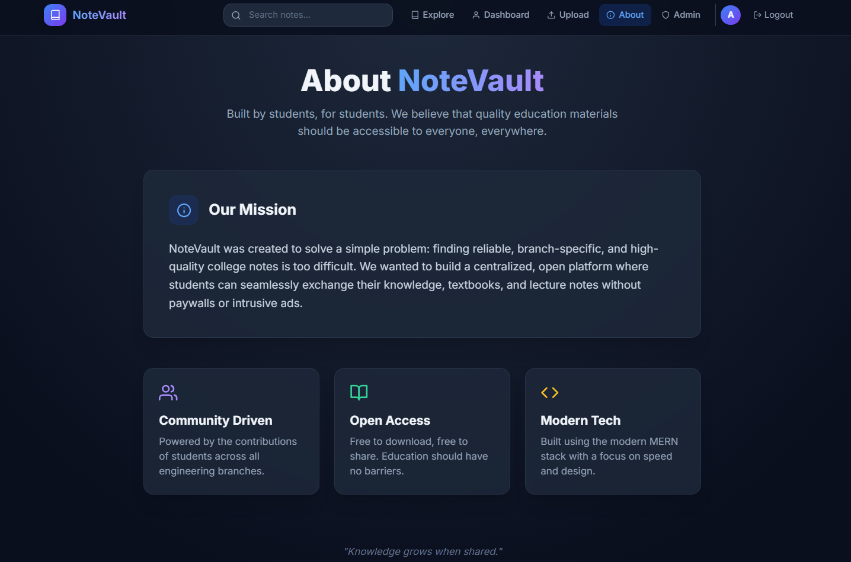

Demo Video Link
https://drive.google.com/drive/folders/1y0AQQ6xGZt06Gomm3kyrJihH3SO3tls7?usp=sharing

Code Files:
https://drive.google.com/drive/folders/1YkwOKB0q8Dc4s34xOVZcKkjY5WTdt1a8?usp=sharing

Github Repo Link:
https://github.com/Jaswanth-techie/Student-notes-exchange-portal

